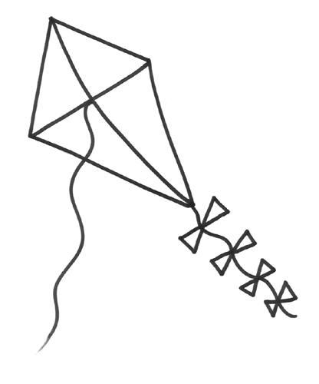

It is a kite parade!

It is a kite parade!

It is a kite parade!

It is a kite parade!

It is a kite parade!

It is a kite parade!

