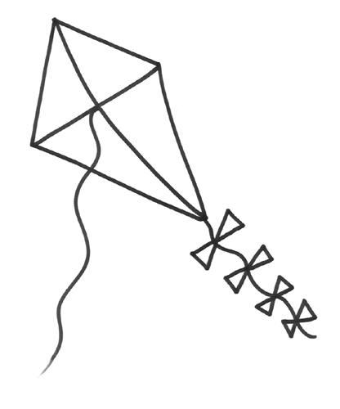
A ____________ kite flies.

A ____________ kite flies.

A ____________ kite flies.

A ____________ kite flies.

A ____________ kite flies.

