Roll - A - Snowman
.
Take turns. Roll a number cube and follow the directions.
Use a dry erase marker to draw on your snowman.
The first one to finish all the parts of their snowman is the winner.

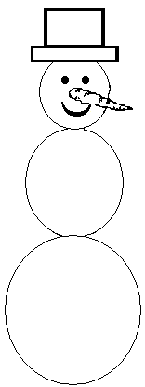 Color the hat.
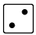Trace the head.

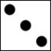 Trace the top body.

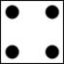 Trace the bottom.

 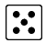Color the eyes and mouth.
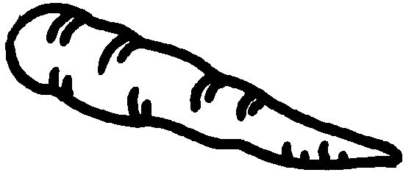  Color the carrot nose.

