We’re Ready!

The Rules
1, 2… Here’s what we do.

3, 4… Bottoms on the floor.
5, 6… No talking lips. 

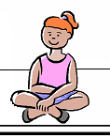
7, 8… Sit up straight.
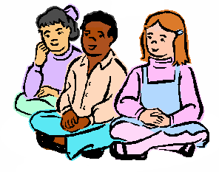
9, 10… Now let’s begin!

