Name______________________________________________
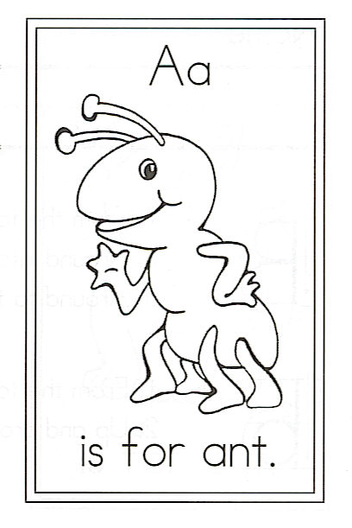

Draw an ant.

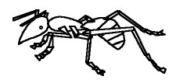

Circle the words:
ant ants to dogs

A is for Ants

When the ants came to the picnic,
It wasn’t very fun.

They ate up all the hot dogs
And munched on every bun.

They got into the salad,
The chips, and chocolate cake.
They even got into my pants.
What next, for goodness sake!

