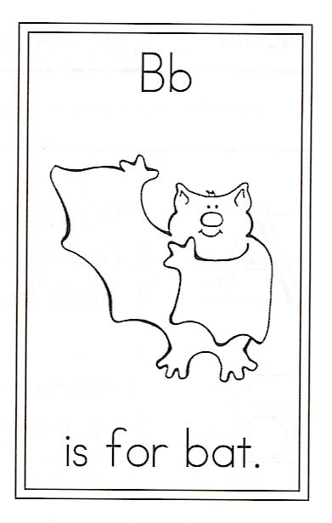
Name_______________________________________________

Draw a bat.

Bats Tune: Twinkle, Twinkle

Circle the ending ing

Circle the words: and the bat bats Bats

Flying, flying in the sky,
Bats are cool, I'll tell you why.
Flying foxes are the tallest,
Bumblebee bats are the smallest.
Bats are yellow, red, and brown,
Bats sleep hanging upside-down.
Some eat bugs and some eat fruit,
Some look mean and some look cute.
Flying, flying in the sky,
Bats are cool, now you know why!

