Name_____________________________________________
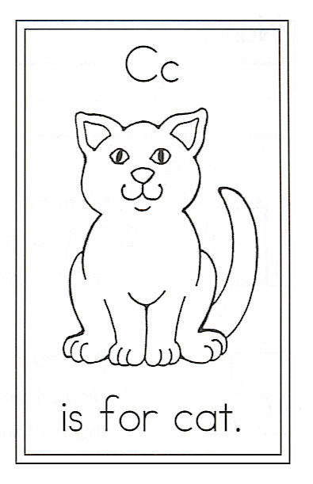
Draw a cat.

Circle the words:
cat “ing” you
Challenge
Write the word at the beginning
of these sentences:

5.

6.

7.

8.

9.

10.

11.

12.

C is for Cat

1. Chasing shadows,
2. Chasing string,
3. Cat, you are
4. A wonderful thing.
5. How you strut
6. When you walk about.
7. How you meow
8. When you want out.
9. Then you curl
10. Up on my lap
11. And purr, purr, purr
12. While you nap, nap, nap.

