Name______________________________________________
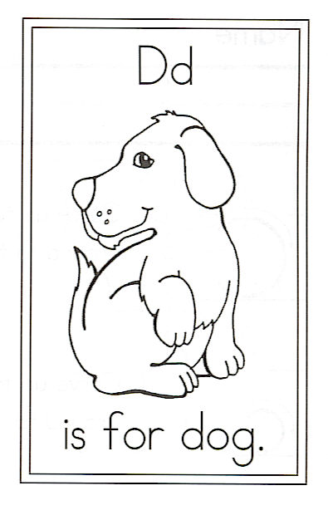
Circle the words:
go and dog they
And Dogs They
Draw a dog.

D is for Dogs

Dogs bark;
They howl and moan.
They roll in dirt
And chew a bone.
They lick your face
And scratch their fleas.

Then they go running
Wherever they please!

