Name______________________________________________
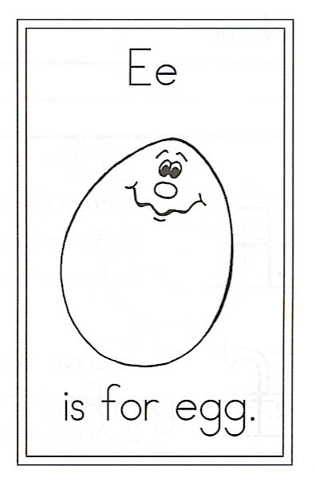

Circle:

the ending “ing” How many?____
the ending “ed” How many? ____

Highlight:

eggs egg and is

Eggs are And Is

E is for Eggs
Draw and decorate 3 dyed eggs.

Eggs are excellent.
Eggs are exciting.
Eating eggs
Is most delighting.
Boiled, scrambled,
Deviled, and fried,
Poached, souffléed,
And even dyed.

