Name_______________________________________
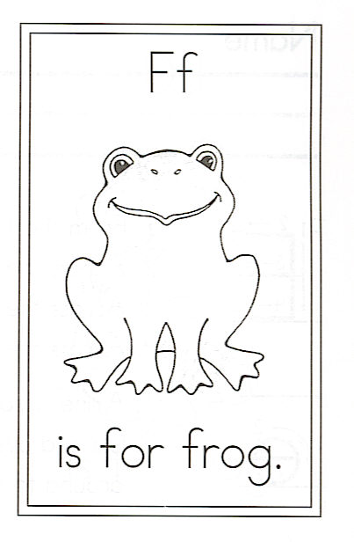
Draw a frog.

Circle the words:

With They Frogs
for they frog

Challenge
frog

What other words
have –og at the end?

____og ____og

F is for Frogs

Frogs can swim
With grace and ease,
Dipping and diving
As they please.
But when they are
Upon the land,
They leap about
As best they can.

