Name______________________________________________
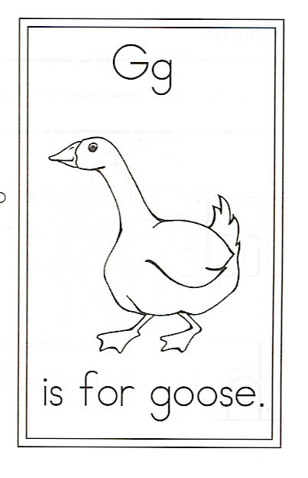
Draw a goose.

Circle the words:
his for is goose

His Goose And

G is for Goose

A goose is so loud
And quite often nasty!
His honk is atrocious.
His manners are ghastly!
He’ll chase you around
For no reason at all,

With his curled-up tail
And a neck that’s too tall!

