Name_________________________________________

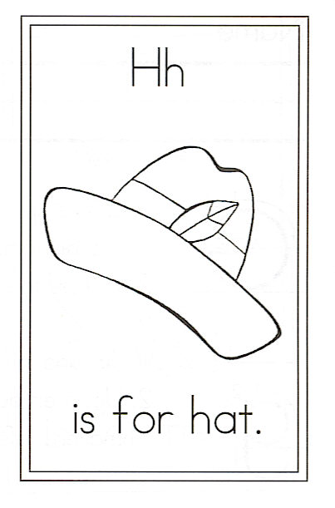
Draw more than 1 hat.

Circle the words: my to it hat

H is for Hat

I have a hat upon my head,
But I really don’t know why.
Does it make me look more charming?
Does it shield sun from my eyes?
Is it there to keep my head warm?
Or to keep the rain at bay?

Is it simply there to rest awhile
So I don’t have to put it away?

