Name______________________________________________

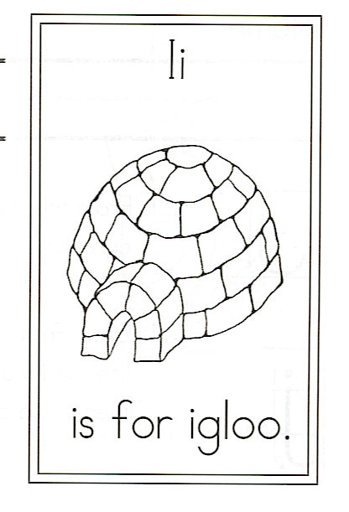
Draw an igloo.

Circle the words:
the is to And Igloo
and igloo

I is for Igloo

Little igloo of ice and snow,
A cozy place for me to go
To sit around the fire’s glow
And talk about the day.

Little igloo in the cold,
I love the stories we are told
Of polar bears fierce and walrus bold,
And seal pups at play.

