Name______________________________________________
J is for jingle bell.
Draw a jingle bell.
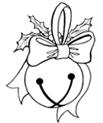

Circle the words: I Jingle jingle Ring ring

Jingle, jingle, little bell,
I can ring my little bell.
Ring it high.
Ring it low.
Ring it fast.
Ring it slow.
Jingle, jingle little bell,
I can ring my little bell.

