Name_____________________________________________
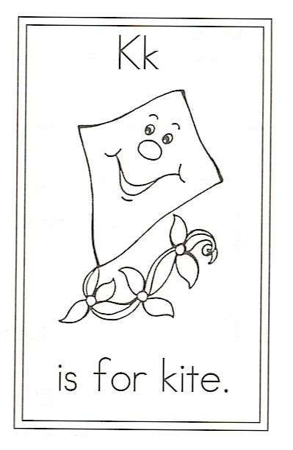
Draw a kite.

Circle the words:
the little kite so high

Challenge

Which words end with “y”

1.

2.

Which words have “gh”

1.

2.

K is for Kite

Fly so high, little kite,
Past the trees, then out of sight.
Soar beyond the clouds so high,
Climbing up to touch the sky.

