Name______________________________________________________________________
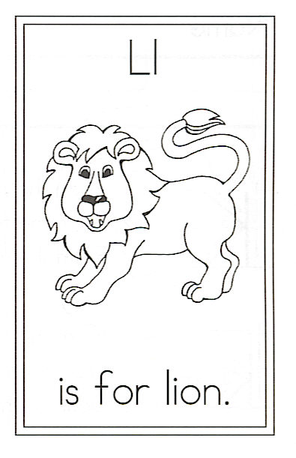
Draw a little lion.

Circle all the words that are on our Word Wall.
http://mrsjonesroom.com/jones/wordstolearn.html

L is for Lion
Strategy: find little words
or chunks in big words

denying

king

wisdom

beneath

trees

whenever

Little lion, there is no denying,
You are the king of beasts.
With your wisdom, strength,
And courage,
No other can compete.

You walk about the water hole,
And nap beneath the trees.
You roar when you are angry
And eat whenever you please.

