Name_____________________________________________
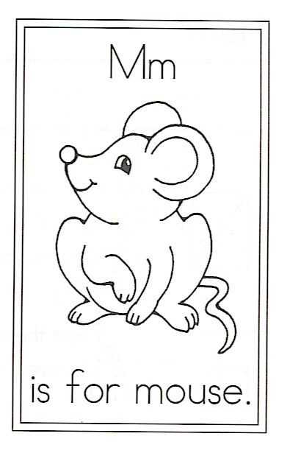
Draw a mouse.

M is for Mouse

A tiny mouse lives in my house;
He steals crumbs and bits of cheese.
I would not mind it near so much
If he would just say please.

He is rather cute and furry,
But he is not welcome here.
Mom would shoo him with her broom,
If she knew a mouse were near.

Find 2 letter words in the poem and write them here. How many did you find?

