Name______________________________________________
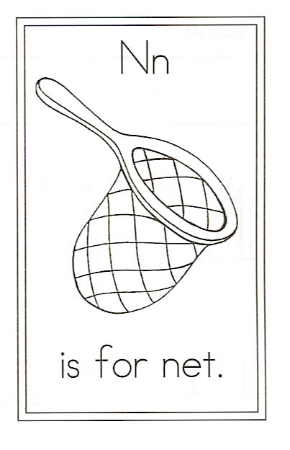
Draw a net.

Circle the words:

And my she her net
Net

N is for Net

I caught a butterfly in my net,
Draw a butterfly.
But she fluttered frantically.
So I let her out
And watched her go,
Then she glided back to me.

She perched upon my shoulder,
And my arm she tiptoed down.
She sat upon my finger,
Then left without a sound.

