Name______________________________________________
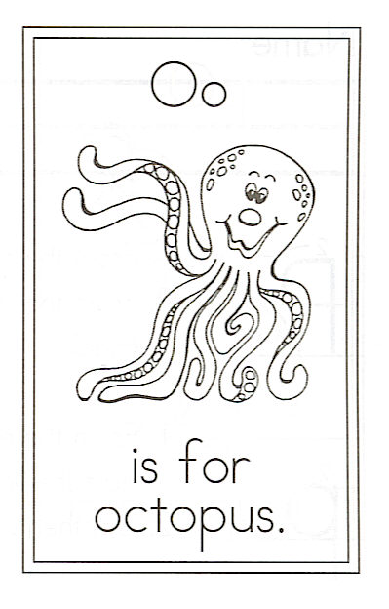
Draw an octopus.

Find the words:
I Octopus octopus you

O is for Octopus

Oh, I wish I were an octopus
With eight graceful arms.
I would wrap them all around you
And keep you safe from harm.

