Name______________________________________________
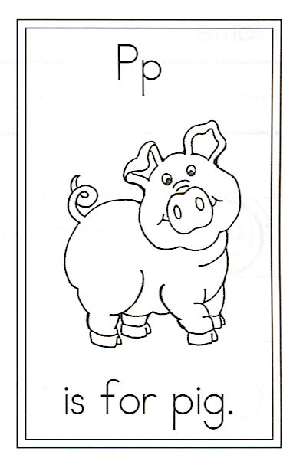
Draw a pig.

Circle the words: At a to and pig

P is for Pig

Two mother pigs lived in a pen
Each had four piglets and that made ten.
All eight piglets loved to play,
And they rolled and they rolled
in the mud each day.

At night with their mothers,
they curled up in a heap,
And squealed and squealed
till they all went to sleep.

