Name_____________________________________________
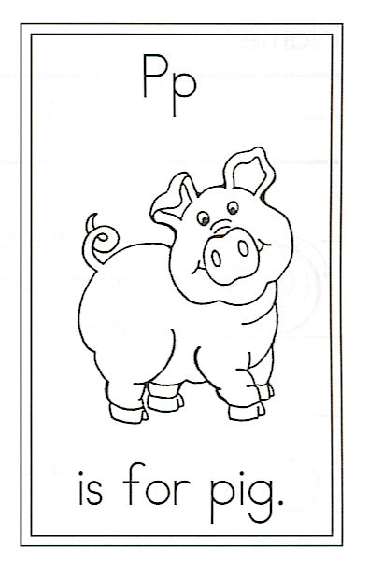
Draw a pig.

Circle the words:

I a To pig . period

P is for Pig

I called my little piggy
To feed him a bucket of slop.
He asked me for another,
And still he would not stop.

With a grunt and oink and squeal,
He demanded another meal.
When I told him, “Not today!”
He packed his bags and moved away.

