Name_____________________________________________
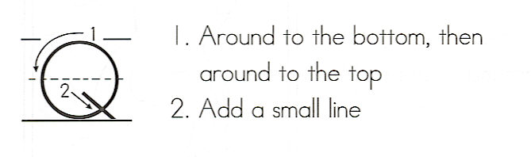
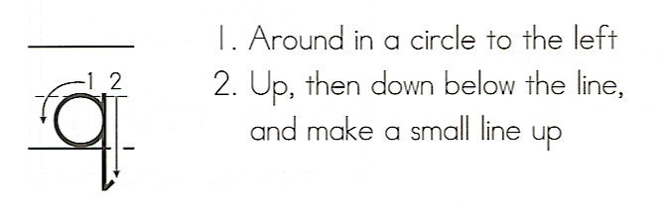

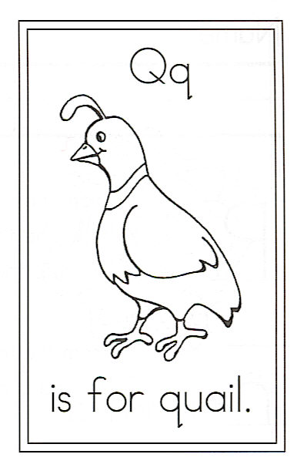
Draw a quail.

How many commas? _____ ,
Circle: quail in and the
Quail In “ing” “noisy ee’s”

Q is for Quail

Gentle little valley quail,
In the bushes and on the trail,
Scurrying in the grass and weeds,
Seeking berries, bugs, and seeds.

