Name______________________________________________
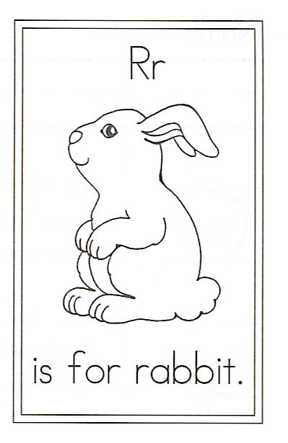
Circle thewords:

R is for Rabbit

Hip, hop, hippity hop,
The rabbit is at play.
His ears will flop.
His nose will twitch.
I wish that he would stay.

Hip, hop, hippity hop,
The rabbit has gone away.
Night has come,
And his burrow is warm.
He simply couldn’t stay.

