Name______________________________________________
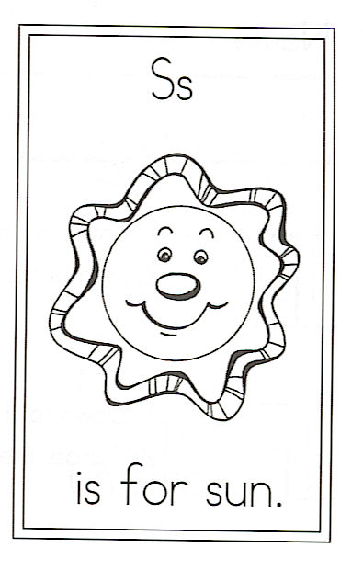
Draw the sun.

Circle the words:

hot sun me
Challenge

Which 3 words end with
the chunk “ay?”

1.

2.

3.

Find 3 words that have a
“silent e” at the end.

1.

2.

3.

.

S is for Sun

Bright sun, hot sun,
Shine on me today.
Make this morning special,
Watch me while I play.

Bright sun, hot sun,
Chase the clouds away.
Bring along a rainbow
To give me luck today.

