Name______________________________________________

Circle the letters T t.
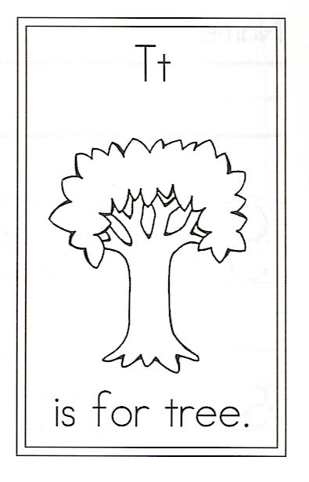
Draw a tree.

T is for Tree

How wonderful to be a tree,
Making shade for you and me,
Holding a hive for the honeybee,
Hiding the nest of a chickadee,
Reaching as high as we can see.
How wonderful to be a tree.

