Name_____________________________________________
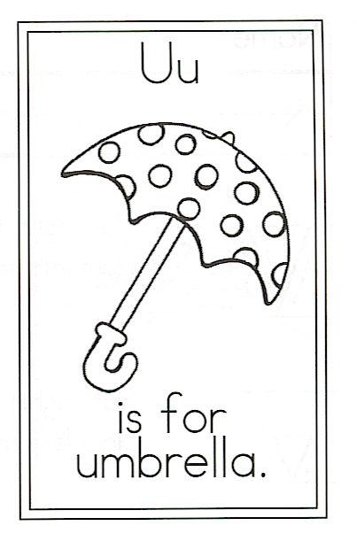
Draw an umbrella.

Circle the words:

My For And Umbrella
my for and umbrella

U is for Umbrella

Under my umbrella,
Under cloudy skies,
I wish for thunder to rock and roll,
For lightning to strike,
Count the punctuation marks on this page.
. period _____

, comma _____

? question mark _____
And winds to blow.

I’m wearing my hat,
My boots, and my coat.
Oh, rain, wherever did you go?

