Name_____________________________________________
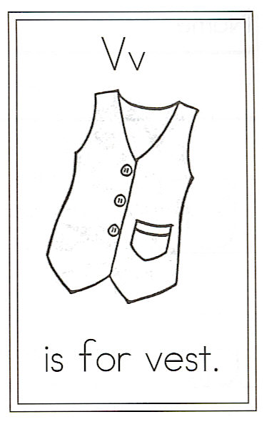
Draw a vest.

Circle the words:
have is Vest It
with and vest it
How many 3 letter words can you find? Write them in this box.

1.

2.

3.

4.

5.

6.

7.

8.

V is for Vest

My vest has many colors.
It is soft, woolly, and new.
It is stitched with love and care.
I hope you have one too.

It keeps me snug and warm
When I am at school or play.
It makes me feel so special,
So I wear it every day!

