Name_____________________________________________
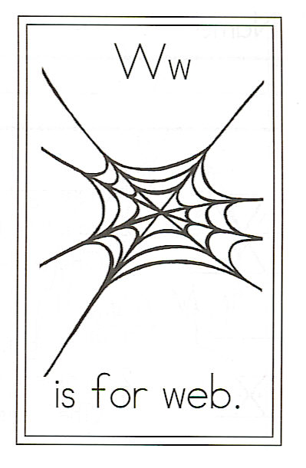
Draw a web.

Circle the words:

Her web for

Challenge

Find 2 words that
end with “ight”

1.

2.

Find 2 words that
end with “y”

1.

2.

W is for Web

Spider spins
Her web at night,
With strands so sticky,
Fine, and tight.
Her webs aren’t meant
For you or me,
But for the bugs
She finds tasty.

