Name______________________________________________
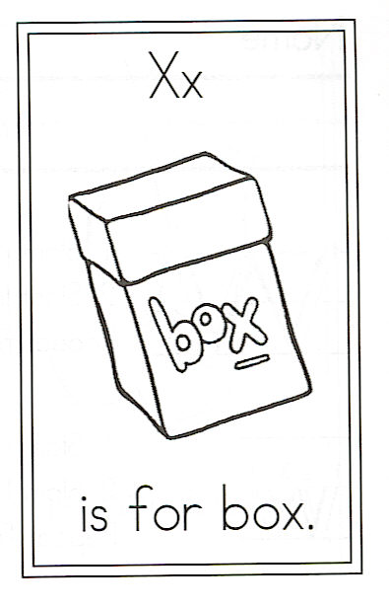
Draw a box.

Circle the words:

box Boxes boxes

X is for Boxes

Big boxes,
Little boxes;
Tall boxes,
Small boxes;
Boxes lined up in a row,
Boxes tied up with a bow.
But what’s inside?
I’d like to know!

