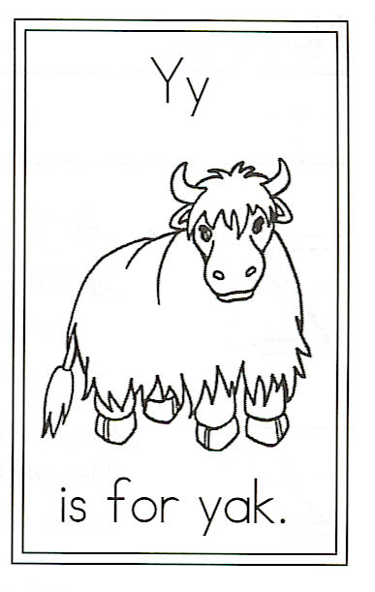
Name_____________________________________

Y is for Yak

There was a yak
Who lived out back.
He grazed all day,
Swishing flies away.

He wore a coat,
All shaggy and brown.
It was so long,
It touched the ground.

Then without a single word,
He left one day to join a herd.

