Name_________________________________________
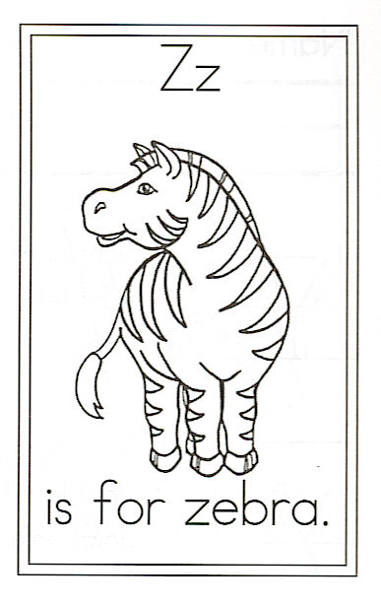
Draw a zebra.

Circle the words:

Challenge

Find 2 color words.

1.

2.

Find 2 words that rhyme.

1.

2.

Find a number word.

1.

Is it It is zebra

Z is for Zebra

Is it black on white,
Or white on black?

With four sturdy legs
And a whinny that begs
For carrots crunchy
And apples munchy.

Is it a horse? No,
It is a zebra, of course.

