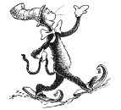 Would you tell your mom
if the Cat in the Hat
came to your house? Why?

