Name________________________________ 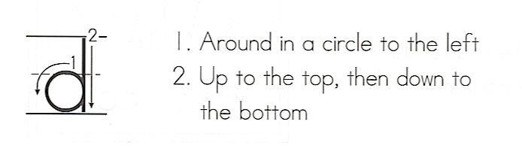do
Write the word 3 times.
__________________
1. _ _ _ _ _ _ _ _ _ _ _
__________________
__________________
2. _ _ _ _ _ _ _ _ _ _ _
__________________
__________________
3. _ _ _ _ _ _ _ _ _ _ _
__________________

Color the boxes with the word.
do | do | to | so
so | do | do | lo
po | 6o | do | do
to | go | bo | do

Circle the word in the sentences.

Do you have gym on Monday?
Yes, I do have gym on Monday.
We do not run at Play Time.
Do you like pizza?

