Name_________________________________________
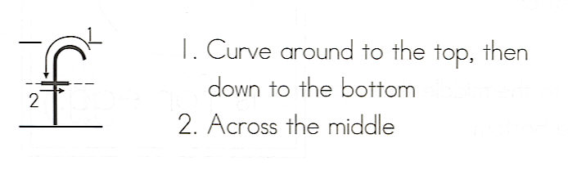
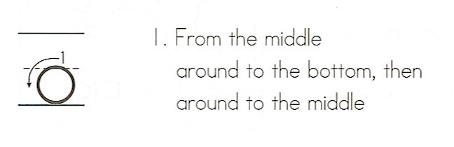
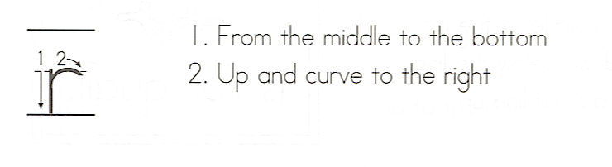

for
Write the word 3 times.
__________________
1. _ _ _ _ _ _ _ _ _ _ _
__________________
__________________
2. _ _ _ _ _ _ _ _ _ _ _
__________________
__________________
3. _ _ _ _ _ _ _ _ _ _ _
__________________

Color each word a different color.
fur | far | fir | for
for | for | far | fir
fur | far | for | for
for | fur | for | fur

Circle the word in the sentences.

1. Do you have a milk for me?
2. The apple is for my Mom.
3. Run for your life!
4. Go look for your Dad.
5. What do you like for dinner?

