Name_____________________________________
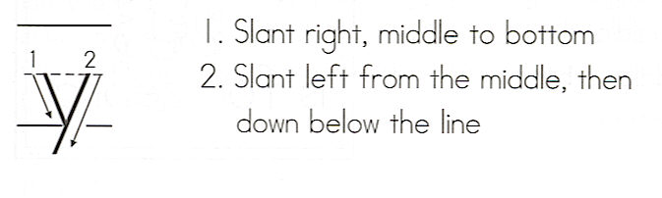
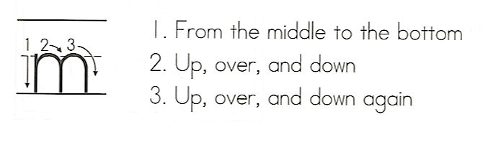

my
Write the word 3 times.
__________________
1. _ _ _ _ _ _ _ _ _ _ _
__________________
__________________
2. _ _ _ _ _ _ _ _ _ _ _
__________________
__________________
3. _ _ _ _ _ _ _ _ _ _ _
__________________

Use a different color for each word.
my | are | am | My
to | my | is | am
are | are | my | to
My | is | am | my

Circle the words in the sentences the same colors as in the puzzle.

1. I like to play with my friend.
2. I am going to my room.
3. Where are my boots?
4. Can you see my Dad?
5. My Mom is the best!

