Name_________________________________________
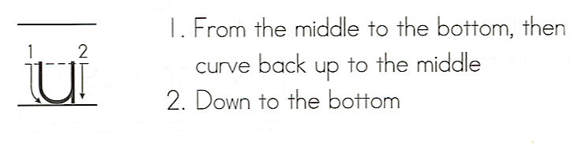
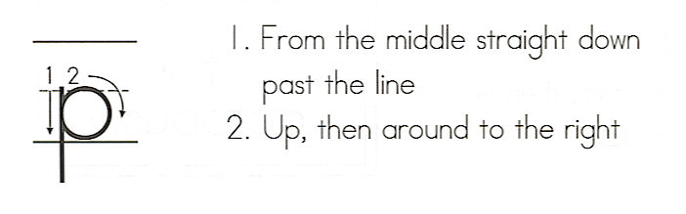
up
Write the word 3 times.
__________________
1. _ _ _ _ _ _ _ _ _ _ _
__________________
__________________
2. _ _ _ _ _ _ _ _ _ _ _
__________________
__________________
3. _ _ _ _ _ _ _ _ _ _ _
__________________

Color the boxes with the word up.
go | are | up | do
up | can | up | see
and | up | my | you
up | is | up | to

Ring the word up in red. Box the words that are in the puzzle.

1. What are you up to?
2. Clean up time!
3. Did you pick up your toys?
4. I woke up and saw snow!
5. How do you go to gym? (Use up in your answer.)

