Name_________________________________________
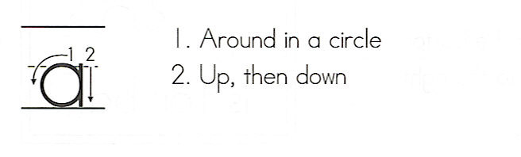
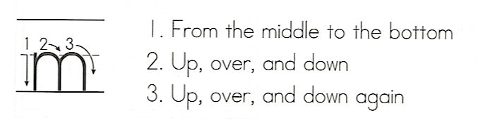
am
Write the word 3 times.
__________________
1. _ _ _ _ _ _ _ _ _ _ _
__________________
__________________
2. _ _ _ _ _ _ _ _ _ _ _
__________________
__________________
3. _ _ _ _ _ _ _ _ _ _ _
__________________

Color the boxes with am in blue.
am | a | am | you
I | to | the | not
am | am | to | am
at | not | am | Are

Ring the word am in blue. Box the words that are in the puzzle.

1. I am going to gym.
2. I am not a yellow dog.
3. I am eating or reading!
4. I am not at the green exit.
5. Are you a girl or a boy? (Use am in your answer.)

