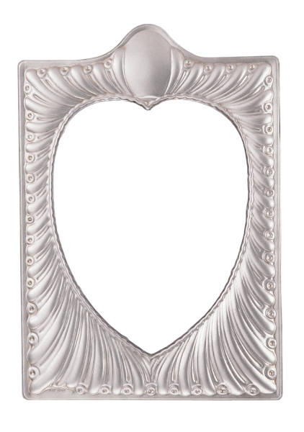 Mother My Dear
Tune: Rock-A-Bye Baby

Mother my darling,

Mother my dear,

I love you,

Each day of the year.

You are so sweet,

And you are so kind,

And I am so glad,

That you are mine!

