Where is the Pumpkin?
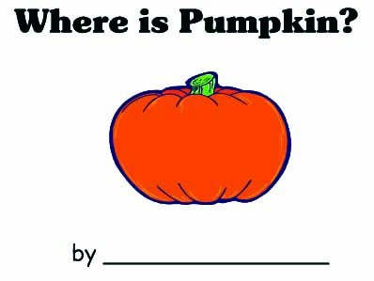

Where is the pumpkin?
The pumpkin is beside a tree.

Where is the pumpkin?
The pumpkin is on the fence.

Where is the pumpkin?
The pumpkin is in the garden.
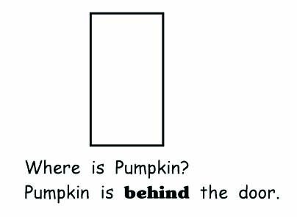

Where is the pumpkin?
The pumpkin is under the moon.

Where is the pumpkin?
The pumpkin is now a pumpkin pie!

Where is the pumpkin?
The pumpkin is behind the door.

