Name -ow word family

Write the name of each picture on the lines.

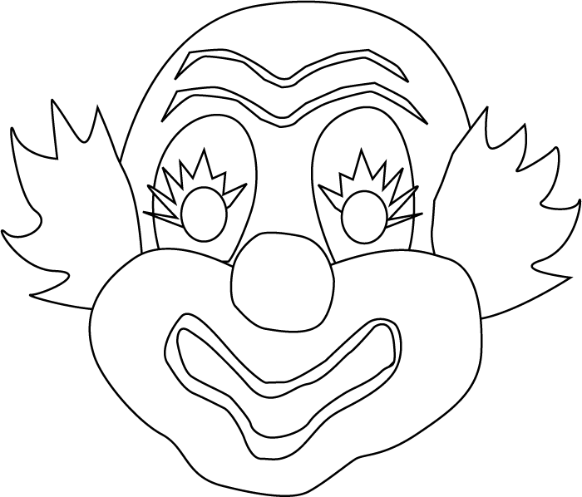

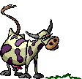
color?

-ow Spell and Write
Cherry Carl 2004
Graphics: PrintMaster Platinum 12 and Microsoft Office Clip Art

